**NAME:** KOGANTI NAVYA

**ROLL NO:** 2420030180

**SEC:** S-2

Task 3

**Configuration of basic switch setup using Huawei/Cisco network switch using cisco packet tracer. Procedure:**

**Step 1: setting up the network Topology**

1. Open cisco packet tracer

2. Add devices:

• Drag and drop a cisco switch

• Drag and drop two PC’s example PC0, PC1

3. Connect devices:

• Use the connections option to select the copper straight through cable

• Connect each PC to the switch using the FastEthernet ports (e.g., PC0 – FastEthernet0/1, PC1- FastEthernet0/2)

**Step 2: Configuring the Switch:**

1. Open the CLI of the search:

• Click on the switch and go to the CLI tab.

• Enter the following commands:

Switch>enable

Switch#configure terminal

Enter configuration commands, one per line. End with CNTL/Z.

Switch (config) #hostname #1

#1 (config)#interface vlan 1

#1 (config-if)# ip address 192.168.1.1 255.255.255.0

#1(config-if)#no shutdown

#1(config-if)#

LINK-5-CHANGED: Interface Vlanl, changed state to up

LINEPROTO-5-UPDOWN: Line protocol on Interface Vlanl,

changed state to up

#1 (config-if)#exit

#1 (config)#exit

#1#

\SYS-5-CONFIG_I: Configured from console by console

#1#write memory

Building configuration...

[OK]

#1#

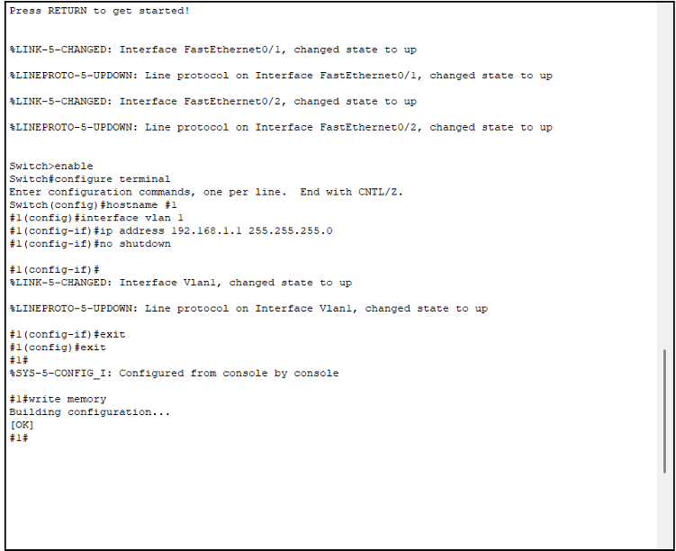 **Step 3: Configuring the PC’s**

1. Assign IP address to PCs:

• Click on each PC and got to the desktop tab

• Open the IP configuration and assign the IP address within the same subnet as the switches VLAN1 interface.

For example:

• PC0 IP address: 192.168.1.2, Subnet Mask: 255.255.255.0

• PC1 IP address: 192.168.1.3, Subnet Maks: 255.255.255.0

**Step 4: Testing connectivity**

1. **Ping between PCs:**

• Open the command prompt on one of the PCs

• Use the ping command to check connectivity to the other PC (e.g Ping 192.168.1.3)

